Git commands workflow real-time scenario

🧑‍💻 Scenario:
You and your friend are working on the same project.
- You: working from India 🇮🇳
- Your friend: working from USA 🇺🇸
- You both are collaborating using GitHub (remote repository).
Workflow :

Initial Setup:

✅ Step 1:
Repo name: git-collab-practice
You both clone the same GitHub project to your local machines.
git clone <repo-url>

✅ Step 2: Clone the repo as "Developer 1" (You – India)
mkdir -p ~/project/developer1
cd ~/project/developer1
git clone https://github.com/your-username/git-collab-practice.git .

✅ Step 3: Clone the same repo as "Developer 2" (Friend – USA)
mkdir -p ~/project/developer2
cd ~/project/developer2
git clone https://github.com/your-username/git-collab-practice.git .

👨‍💻 Developer 2 (USA) - Makes a change and pushes

cd ~/project/developer2
echo "Hello from USA" > usa.txt
git add usa.txt
git commit -m "Added usa.txt"
git push origin master

👨‍💻 Developer 1 (YOU - India) - Makes a change and tries to push

cd ~/project/developer1
echo "Hello from India" > usa.txt
git add usa.txt
git commit -m "Added usa.txt"
git push origin master

❌ You'll get this:

! [rejected] master -> master (fetch first)

✅ Now pull before push
git pull origin master
after pulling make changes again same steps repeate
git add <filename>
git commit -m “msg”
# (This will merge both changes)
git push origin master

❌ if get this error below means That error means Git is trying to pull or push from a remote named origin, but:
- Either you didn’t set the remote URL using git remote add origin <URL>, or
- The remote URL is incorrect or doesn’t exist, or
- You don’t have permission (e.g., private repo and you're not authenticated)

🔧 Step 1: Check if a remote is set
git remote -v
Expected Output: If it’s empty, that’s why the error happened.

git remote add origin https://github.com/veerashiv/git_collab_practice.git

🔧 Step 3: Now try push or pull

git pull origin master
# or
git push -u origin master

after changing anything developer1 ,how developer2 will identy what changes made by developer1 we can use one command

git log Shows Who Committed What commit id’s will there
using that commit id changes will see
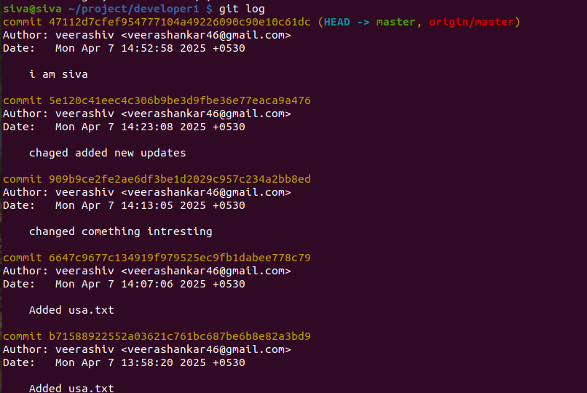

git show <commit_id>
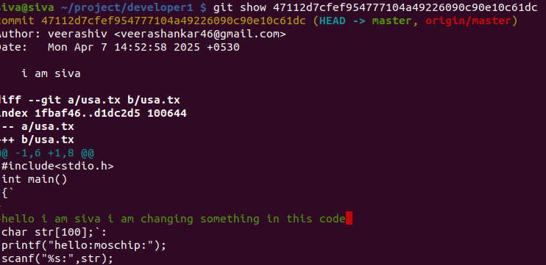

one example :i created one file that file name string.c
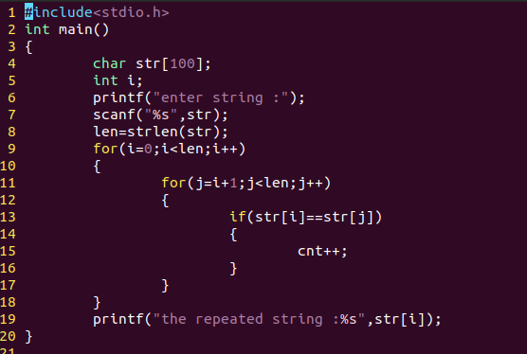
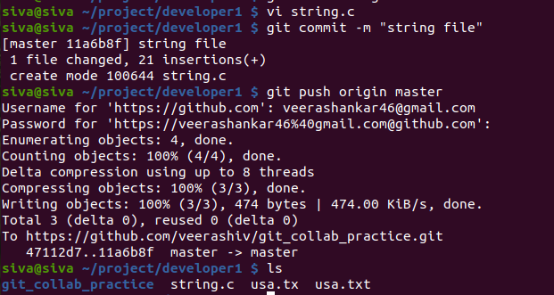

above process I did developer1 file created and adding commit push now same file, now I want that file into developer2 I will push do pull before changing anything u need pull first-stage

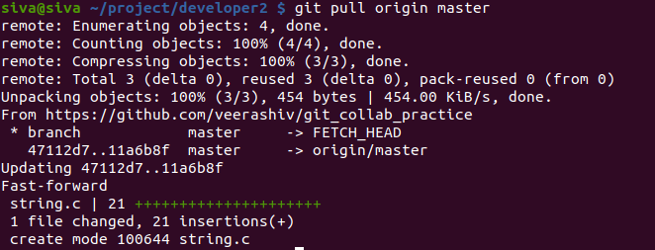
here I open that string.c file I did some changes in that file
now again I have to these below steps
git add string.c
git commit -m “added new function”
git push origin master
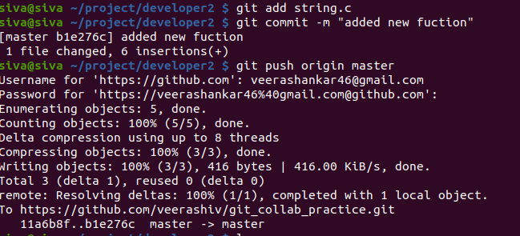
now I am using developer1 string.c file only
have pull that file file because any changes made develop2 it will reflected
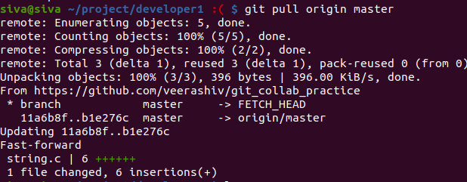
latest commits list it will show git log
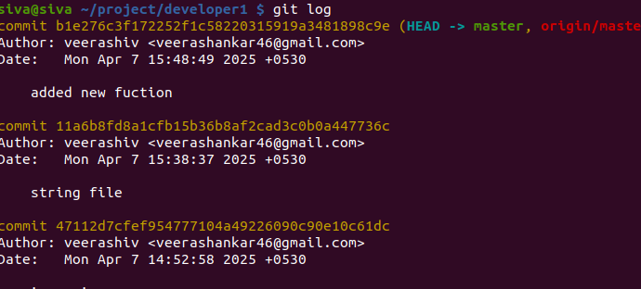
now if I want to know the changes made by develop2 I will that commit id
here we are taking latest commit id

git show <commit_id>
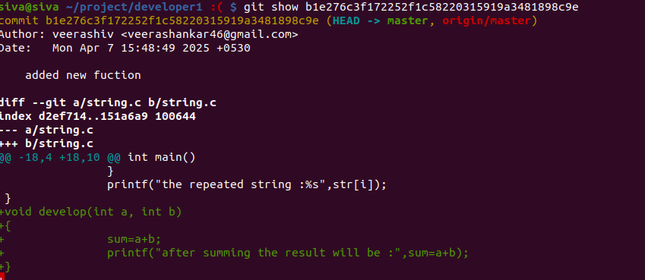
that green color code changes made by develop2

